**ASSIGNMENT – 6**

***Web Application used : Blood Bank & Donor***

***Management System***

***Testing tool used : Selenium***

**Group members**

Anagha

Haritha

Sreelekshmi

Manjima Mohan

Anuja B

**WEB APPLICATION**

**Blood Bank & Donor Management System**

Blood Bank Management System (BBMS) is a Web-based application that is designed to store, process, retrieve and analyze information concerned with the administrative and inventory management within a blood bank.

Project Name : Blood Bank & Donor Management System  
Language Used  :  PHP  
Database :  My SQL  
User Interface Design :  HTML, AJAX,JQUERY,JAVASCRIPT  
Web Browser :  Mozilla, Google Chrome, IE8,OPERA  
Software  :   XAMPP Server Blood Bank & Donor  
 Management System motive at maintaining all the information related to blood donors, different blood groups available in each blood bank and help them manage in a better way.

**Visitor Feature’s ( Front end ):**

* Responsive Template, Mobile Friendly
* Easy to use
* Blood Donor Registration System
* Blood Group and location-based search engine
* Donor Details Information
* Contact us Inquiry

**Admin Feature’s ( Administration Section ):**

* Manage Blood Group(add, delete)
* Add and Delete Donor Information
* Enable and Disable Donors
* Manage Website Pages
* Manage to Contact us Queries
* Update the contact us Info
* Admin Dashboard

**AUTOMATION TESTING**

Automation testing is a Software testing technique to test and compare the actual outcome with the expected outcome. This can be achieved by writing test scripts or using any automation testing tool. Test automation is used to automate repetitive tasks and other testing tasks which are difficult to perform manually.

Manual software testing is performed by a human sitting in front of a computer carefully going through application screens, trying various usage and input combinations, comparing the results to the expected behaviour and recording their observations. Manual tests are repeated often during development cycles for source code changes and other situations like multiple operating environments and hardware configurations.

Automated software testing has long been considered critical for big software development organizations but is often thought to be too expensive or difficult for smaller companies to implement. Smart Bear’s Tools are affordable enough for single developer shops and yet powerful enough that our customer list includes some of the largest and most respected companies in the world.

**SELENIUM**

**Selenium** is a free (open-source) automated testing framework used to validate web applications across different browsers and platforms. You can use multiple programming languages like Java, C#, Python etc to create Selenium Test Scripts. Testing done using the Selenium tool is usually referred to as Selenium Testing.

Selenium Software is not just a single tool but a suite of software, each piece catering to different testing needs of an organization. Here is the list of tools

* Selenium Integrated Development Environment (IDE)
* Selenium Remote Control (RC)
* Web Driver
* 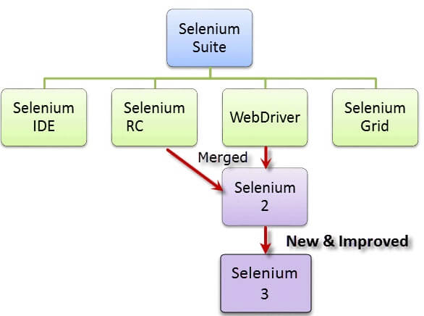Selenium Grid

**Advantages of Selenium**

* **Selenium is an Open Source Software.**
* **Selenium supports various programming languages to write programs (Test scripts)**
* **Selenium supports various operating systems (MS Windows, Linux, Macintosh etc…)**
* **Selenium supports various Browsers (Mozilla Firefox, Google Chrome, IE, Opera, Safari etc…)**
* **Selenium supports Parallel Test Execution.**
* **Selenium uses less Hardware resources.**

**Steps to install selenium WebDriver for windows.**

**Step 1) Install java on windows machine (JDK)**

First verify whether java is already installed on your machine or not go to command prompt and type command “java -version” and press enter.

if java is already installed on your machine then system will give you output like this

java version “1.8.0_73”  
Java(TM) SE Runtime Environment (build 1.8.0_73-b02)  
Java HotSpot(TM) 64-Bit Server VM (build 25.73-b02, mixed mode) ….

If java is not installed then system will give you output like this.

‘java’ is not recognized as an internal or external command,  
operable program or batch file.

If you get above message then click [Install JAVA/JDK here](http://www.oracle.com/technetwork/java/javase/downloads/index.html)

After navigating to above site click on JDK download link as mentioned below.

[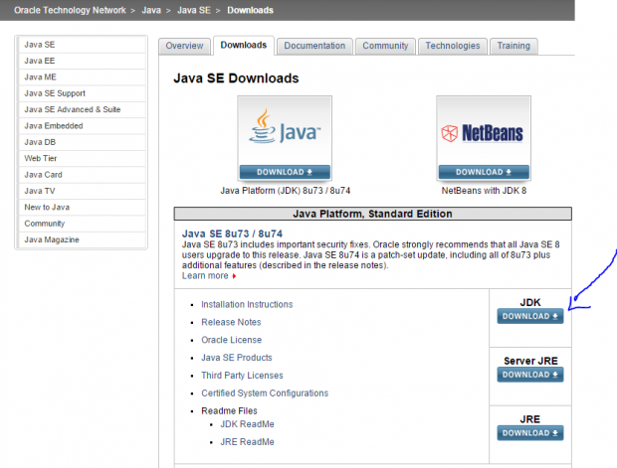](http://mundrisoft.com/tech-bytes/install-selenium-webdriver-windows/install-jdk/)

Then click on Radio Button “Accept License Agreement”

[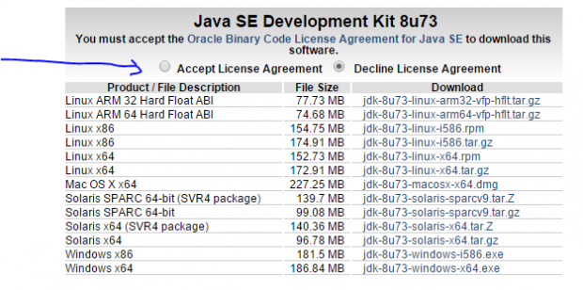](http://mundrisoft.com/tech-bytes/install-selenium-webdriver-windows/acceptlicense/)

If your operating system is 32 bit then click on exe file for “Windows x86” , download it and Run.

if your operating system is 64 bit then click on exe file for “Windows x64” , download it and Run.

**Step 2) Download**[**ECLIPSE IDE from here**](http://www.eclipse.org/downloads/)**.**

Note : Please select appropriate version like 32 or 64 bit which support your windows.

[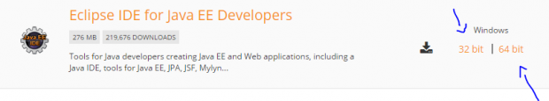](http://mundrisoft.com/tech-bytes/install-selenium-webdriver-windows/eclipsebit/)

Now extract the downloaded zip file to C or D drive or wherever you want.

**Step 3) Download selenium java client driver from**[**here**](http://docs.seleniumhq.org/download/)

Here we are creating the test scripts in java hence we require language specific drivers.

select download link for java as mentioned below

[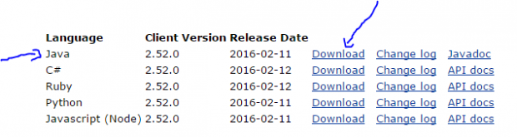](http://mundrisoft.com/tech-bytes/install-selenium-webdriver-windows/javaclientdriver/)

Now extract the downloaded zip file on C or D drive or wherever you want.

For maintenance purpose it is preferable if you placed all your installable or unzip file at one drive.

**Step 4) Install Internet Explorer Driver Server from**[**here**](http://docs.seleniumhq.org/download/)

If application is running on internet explore then we need internet explorer driver.

[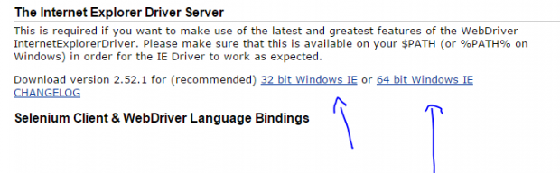](http://mundrisoft.com/tech-bytes/install-selenium-webdriver-windows/iedriverserver/)

Extract the downloaded zip file to C or D driver or wherever you want.

**Step 5) Configure IDE (Eclipse) with Web Driver**

Open the Extracted folder of Eclipse folder (Check Step 2) , Now launch Eclipse.exe

[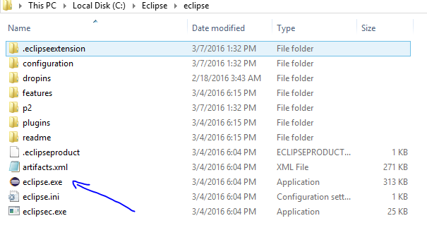](http://mundrisoft.com/tech-bytes/install-selenium-webdriver-windows/eclipselaunch/)

After launching eclipse.exe system will show pop up asking about selecting work space , keep default or select the folder where you want store all your projects. Click on Ok Button

You will receive below screen now**Right Click** on project and select **“Properties”** available under project explorer window shown below.

[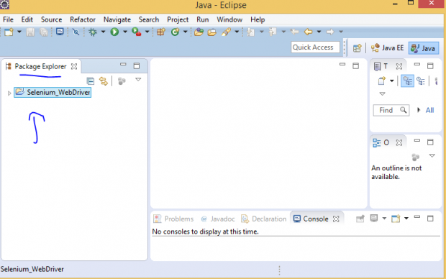](http://mundrisoft.com/tech-bytes/install-selenium-webdriver-windows/rightclick/)

After clicking on properties system will display project property window as shown below

[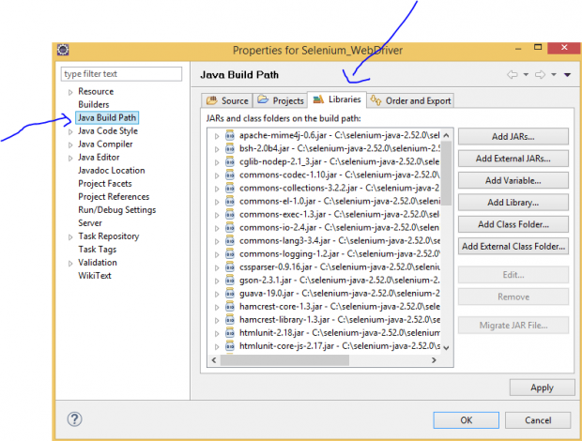](http://mundrisoft.com/tech-bytes/install-selenium-webdriver-windows/propertiesproject/)

Click on Java Build path -> Select Tab “Libraries” … Then Click on Add External JARs

And open extracted folder of selenium java drivers (Refer step 3) …

Now select all JAR file inside and out side lib folder.

click on Apply and Ok…

Now you are ready to use Eclipse to automate application running on Internet Explorer using selenium WebDriver.

**SLIDES TESTING**

package bloodBank;

import org.openqa.selenium.By;

import org.openqa.selenium.WebDriver;

import org.openqa.selenium.chrome.ChromeDriver;

public class User {

public static void main(String[] args) {

System.setProperty("webdriver.chrome.driver", "C:\\Users\\Lenovo\\Desktop\\New

folder\\chromedriver_win32\\chromedriver.exe");

WebDriver driver = new ChromeDriver();

driver.get("http://localhost/bloodbank%20and%20donar%20management%

20system/bbdms/index.php");

driver.manage().window().maximize();

driver.findElement(By.className("carousel-control-next")).click();

String nx= driver.findElement(By.className("carousel-inner")).getText();

driver.findElement(By.className("carousel-control-prev")).click();

String pr= driver.findElement(By.className("carousel-inner")).getText();

if(pr.equalsIgnoreCase(nx))

{

System.out.println("Slide Test Succesfully Completed");

}

else

{

System.out.println("Test Not Successfull");

}

//driver.close();

}

}

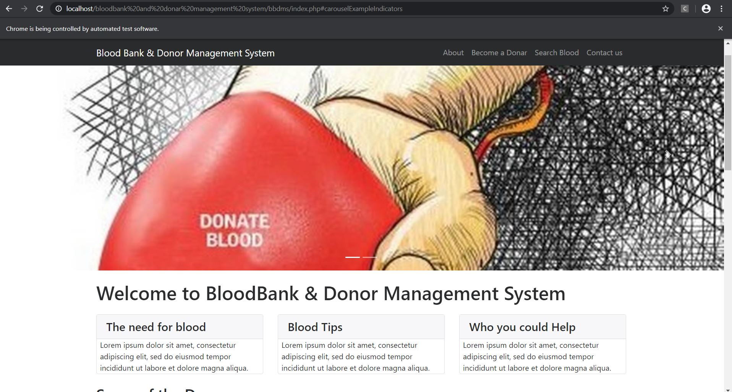

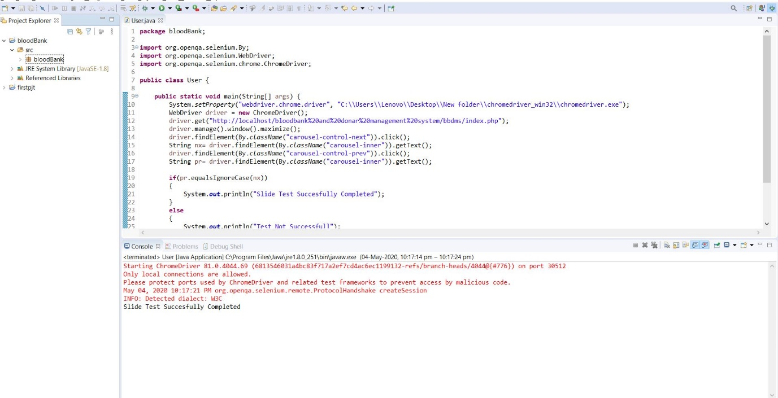

**ABOUT TESTING**

package bloodBank;

import org.openqa.selenium.By;

import org.openqa.selenium.Keys;

import org.openqa.selenium.WebDriver;

import org.openqa.selenium.chrome.ChromeDriver;

public class about {

public static void main(String[] args) {

System.setProperty("webdriver.chrome.driver", "C:\\Users\\Lenovo\\Desktop\\New

folder\\chromedriver_win32\\chromedriver.exe");

WebDriver driver = new ChromeDriver();

driver.get("http://localhost/bloodbank%20and%20donar%20management%

20system/bbdms/index.php");

driver.manage().window().maximize();

driver.findElement(By.id("a")).sendKeys(Keys.ENTER);

String x= driver.getCurrentUrl();

String y= "http://localhost/bloodbank%20and%20donar%20management%

20system/bbdms/page.php?type=aboutus";

if(x.equalsIgnoreCase(y))

{

System.out.println("About us Test Succesfully Completed");

}

else

{

System.out.println("Test Not Successfull");

}

//driver.close();

}

}

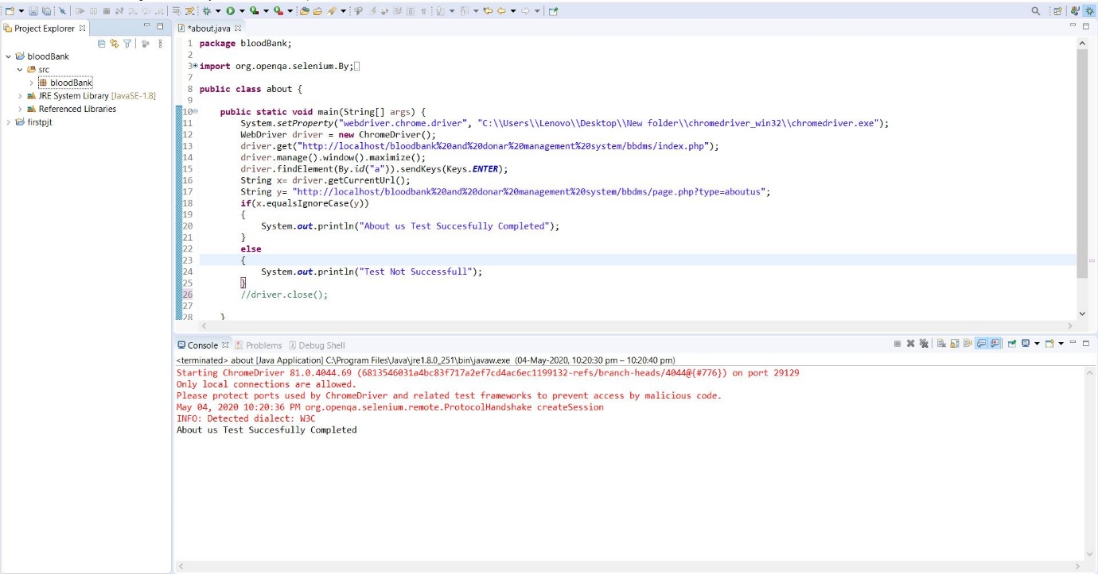

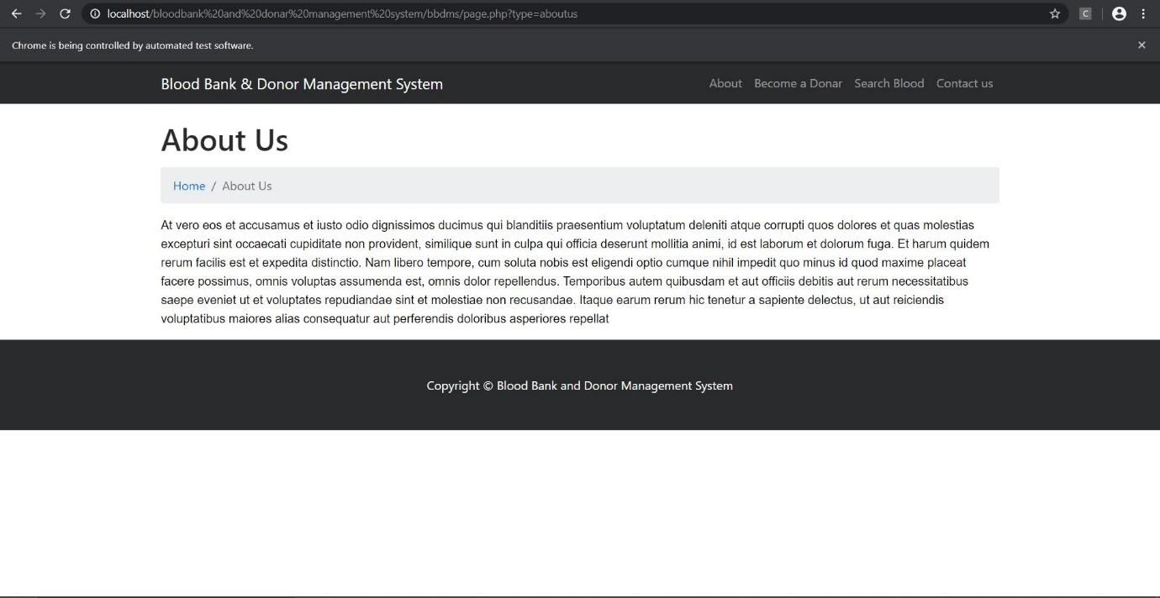

**REGISTERING A NEW DONOR**

package bloodBank;

import org.openqa.selenium.By;

import org.openqa.selenium.WebDriver;

import org.openqa.selenium.chrome.ChromeDriver;

public class doner {

public static void main(String[] args) {

System.setProperty("webdriver.chrome.driver", "C:\\Users\\Lenovo\\Desktop\\New

folder\\chromedriver_win32\\chromedriver.exe");

WebDriver driver = new ChromeDriver();

driver.get("http://localhost/bloodbank%20and%20donar%20management%

20system/bbdms/become-donar.php");

driver.manage().window().maximize();

driver.findElement(By.id("fname")).sendKeys("mm");

driver.findElement(By.id("mob")).sendKeys("9876543210");

driver.findElement(By.id("mail")).sendKeys("manjima@gmail.com");

driver.findElement(By.id("age")).sendKeys("25");

driver.findElement(By.id("add")).sendKeys("Noorumparayil");

driver.findElement(By.id("msg")).sendKeys("none");

driver.findElement(By.id("gn")).sendKeys("Female");

driver.findElement(By.id("bg")).sendKeys("A+");

driver.findElement(By.id("btn")).click();

String e= driver.findElement(By.className("succWrap")).getText();

String f= "SUCCESS:Your info submitted successfully";

if(e.equalsIgnoreCase(f))

{

System.out.println("Doner Submit Test Succesfully Completed");

}

else

{

System.out.println("Test Not Successfull");

}

//driver.close();

}

}

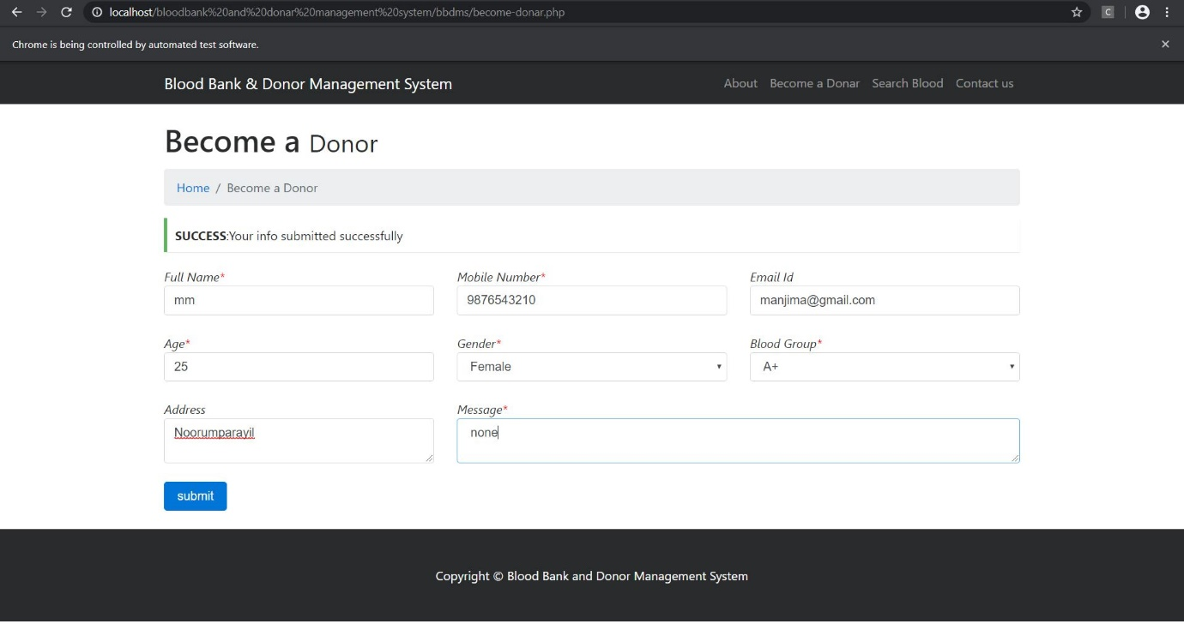

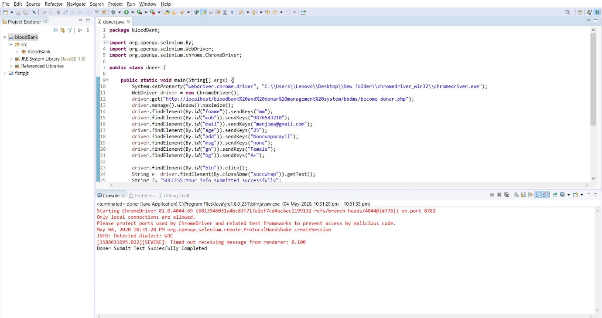

**SEARCH BLOOD**

package bloodBank;

import org.openqa.selenium.By;

import org.openqa.selenium.WebDriver;

import org.openqa.selenium.chrome.ChromeDriver;

public class search {

public static void main(String[] args) {

System.setProperty("webdriver.chrome.driver", "C:\\Users\\Lenovo\\Desktop\\New

folder\\chromedriver_win32\\chromedriver.exe");

WebDriver driver = new ChromeDriver();

driver.get("http://localhost/bloodbank%20and%20donar%20management%

20system/bbdms/search-donor.php");

driver.manage().window().maximize();

driver.findElement(By.id("opt")).sendKeys("A+");

driver.findElement(By.id("btn")).click();

String e=driver.findElement(By.id("row1")).getText();

String f= "No Record Found";

if(e.equalsIgnoreCase(f))

{

System.out.println("Test Not Successfull");

}

else

{ System.out.println("Search Test Succesfully Completed");

}

//driver.close();

}

}

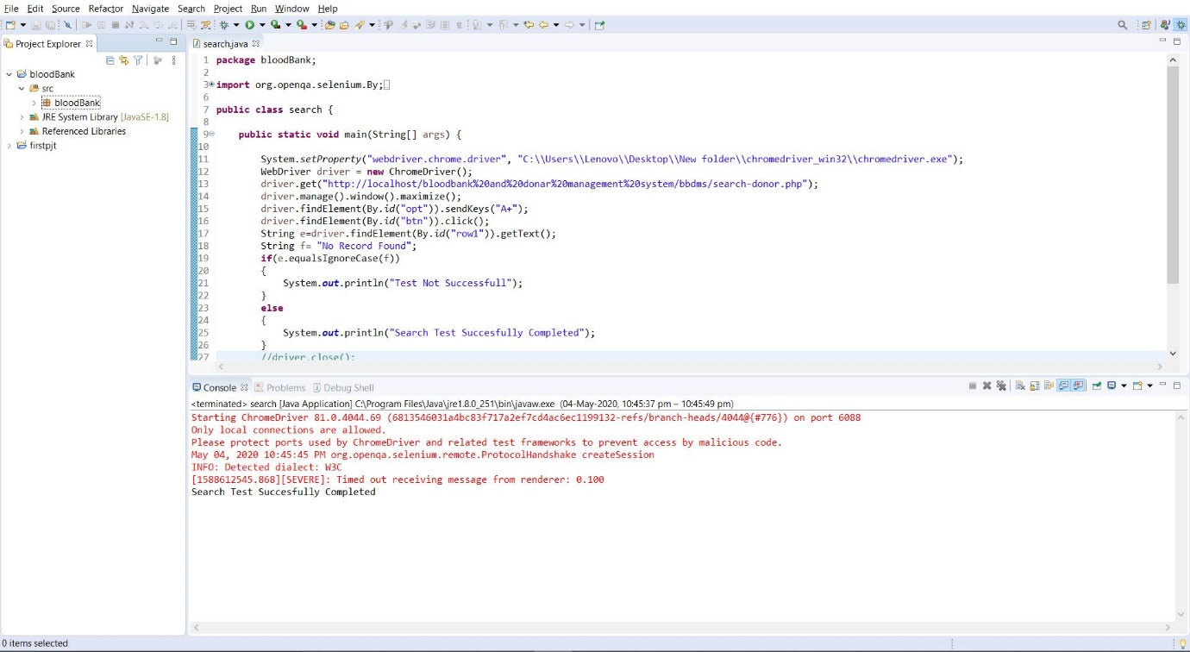

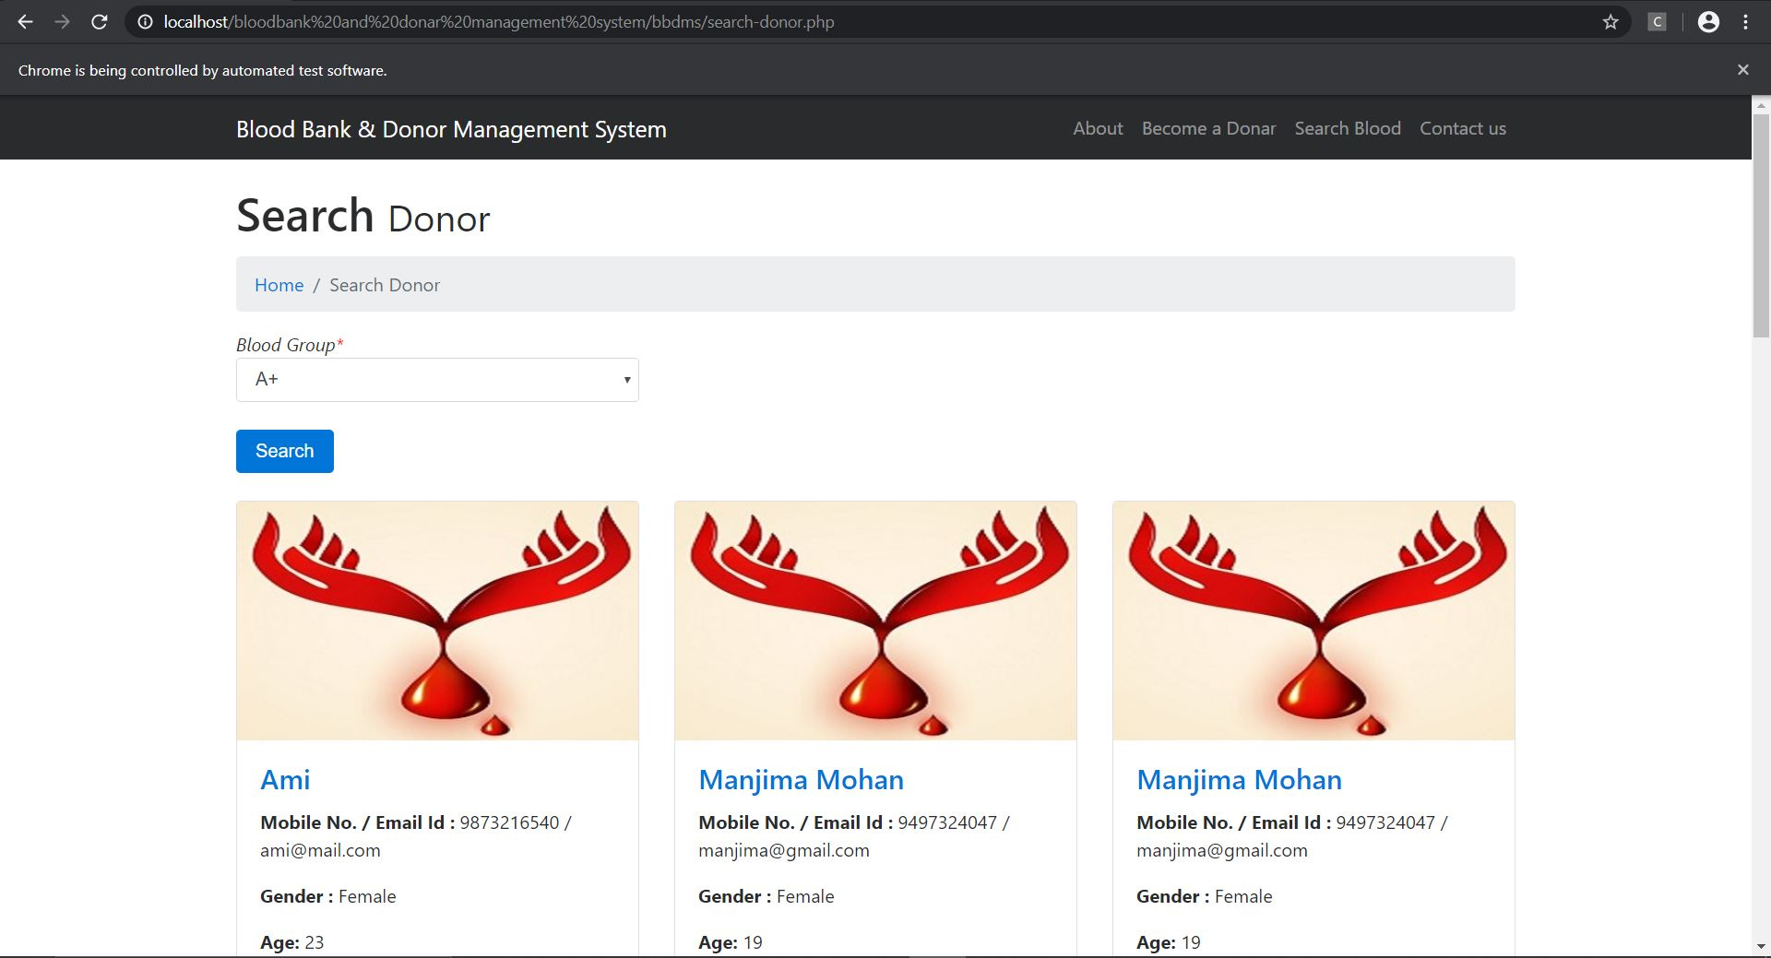

**CONTACT TESTING**

package bloodBank;

import org.openqa.selenium.By;

import org.openqa.selenium.WebDriver;

import org.openqa.selenium.chrome.ChromeDriver;

public class contact {

public static void main(String[] args) {

System.setProperty("webdriver.chrome.driver", "C:\\Users\\Lenovo\\Desktop\\New

folder\\chromedriver_win32\\chromedriver.exe");

WebDriver driver = new ChromeDriver();

driver.get("http://localhost/bloodbank%20and%20donar%20management%

20system/bbdms/contact.php");

driver.manage().window().maximize();

driver.findElement(By.id("name")).sendKeys("mm");

driver.findElement(By.id("phone")).sendKeys("9876543210");

driver.findElement(By.id("email")).sendKeys("manjima@gmail.com");

driver.findElement(By.id("message")).sendKeys("none");

driver.findElement(By.id("btn")).click();

String a= driver.findElement(By.className("succWrap")).getText();

String b= "SUCCESS:Query Sent. We will contact you shortly";

if(a.equalsIgnoreCase(b))

{ System.out.println("Contact Test Successfull");

}

else

{

System.out.println("Test Not Successfull");

}

driver.close();

}

}

